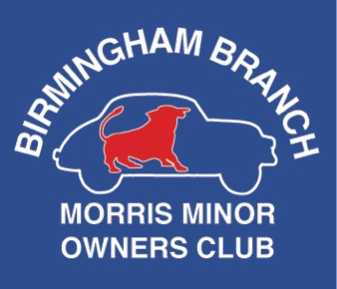 | Fundraising for the Paul Ackrill Fund Charity number: 1090118 | 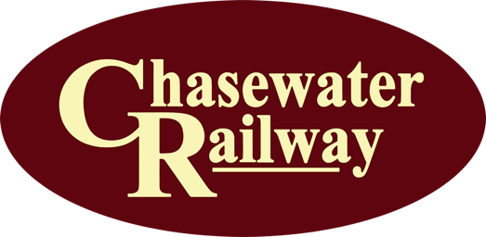

Birmingham Morris Minor Owners Club branch rally
Chasewater Railway, Brownhills Station, Burntwood, Walsall WS8 7NL
Sunday 28 April 2024, entry from 10am (first train 10.30am)
Driver name
Phone number
Email
Would you like to receive news and updates from BMMOC?
- Please add my email address to the BMMOC mailing list: YES / NO
- Please add my mobile number to the BMMOC WhatsApp group: YES / NO

Car make and model
Registration number
Year
All classic vehicles are welcome!
Rally entry fee £5 – all occupants get concession rates on the trains
- Pay in person at a BMMOC branch meeting (held on the third Monday of every month at Hall Green Home Guards Club, 21a Doveridge Road B28 0LS)
- Bank transfers accepted: email birmingham.branch@mmoc.org.uk to submit your form and request our bank details
- Send cheques (payable to ‘Birmingham Branch MMOC’) to Amy Egan, BMMOC Secretary, 106 Moorpark Road, Northfield, Birmingham B31 4HE
Once payment has been received, you will receive an acknowledgement by email or phone, along with details of how to book train tickets at the group rate.
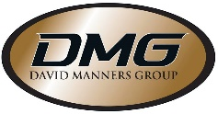 | David Manners Group sponsors Birmingham MMOC branch rally  991 Wolverhampton Road, Oldbury, West Midlands B69 4RJ  Tel: 0121 544 4444 Web: www.davidmanners.co.uk

